Summary

This report introduces the “(logged) data viewer”, abbreviated with (LDV). LDV is part of the data logging package that contains 2 independent applications:

1. Data Logging Application (DLA)
2. Logged Data Viewer (LDV)

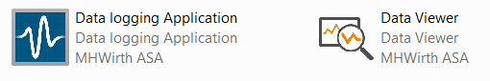

This report is dedicated to LDV.

Table of Contents

1 Objective 1

2 Introduction of functionalities 2

2.1 Main Functionality – Main Features 2

2.1.1 Capture information in a file 2

2.1.2 TDMS File Structure 2

2.1.3 Exchangeability of TDMS file format 3

2.2 User Interface 4

2.2.1 Status Pane 4

2.2.2 Settings Pane 5

2.2.3 Variables Pane 6

2.2.4 Controls Pane 6

2.2.5 View State 7

2.2.6 Defrag State and File Size 9

2.3 File as opened in Microsoft Excel 9

3 Revision History 11

# Objective

The objective is to plot recorded data. It should show the recorded data in two modes. One is while the data is being stored, and the other is as a user-friendly TDMS file reader/viewer.

Main features to achieve:

1. Stand-alone application that can be run on an independent PC (which hosts DLA)
2. Navigate through logged data manually in any desired window
3. View data online as they are being recorded

# Introduction of functionalities

## Main Functionality – Main Features

The application plots the data that are stored in a TDMS file.

LDV has two main modes:

* Online Viewer
* Navigator

### Online Viewer

It is used when the data is being stored in the TDMS file. A window of data (with given size) is being displayed.

### Navigator

It is used when the user prefers to navigate through the stored data. A window of data is shown, and the user can move the window manually. It works both when the data logging application is storing data and when data logging is over.

Navigator can be called offline viewer.

## User Interface

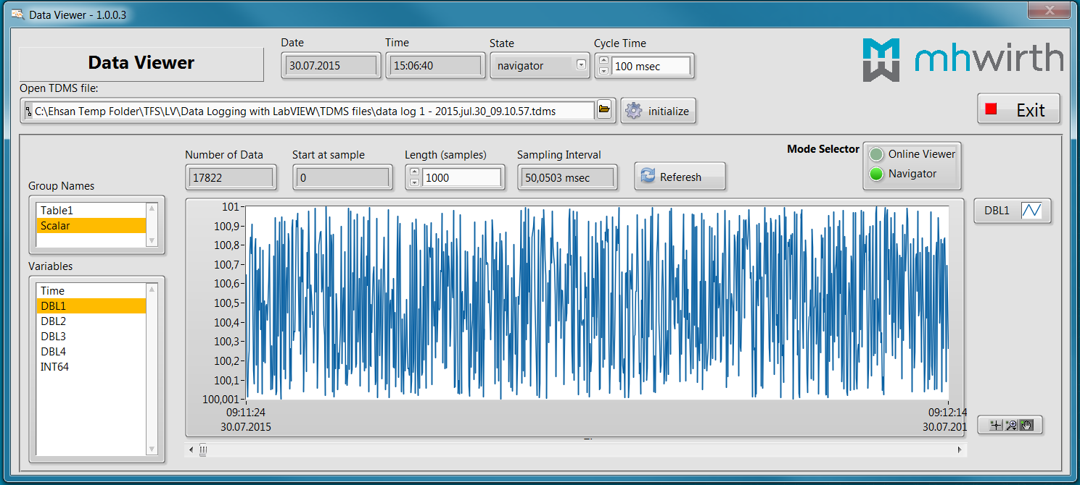

### Status

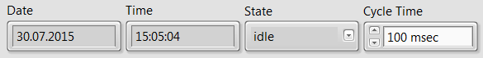

On top of the user interface, data, time and the internal status of the application are shown. The user can determine the cycle time of the application.

It shows the internal state of the application. It can be one the following:

* Initialize
* Idle
* Navigator
* Online Viewer
* Exit

*This is currently the internal state for debugging. As a stand-alone application, it should be changed to user-friendly status bar.*

### Settings

#### TDMS file



The user needs to select the TDMS file (either the file is in use in the DLA or data logging is over), and click on “Initialize” key.

#### Mode Selector

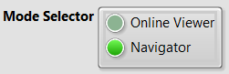

The user shall select one of the modes. The control toggles between these two options.

#### Signals to Plot

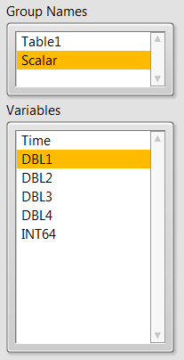

As soon as the TDMS file is selected and initialized, Group Names are updated. Selecting a group name, Variables under the group name are displayed.

The user can select one or more of variables in each group, but only one group can be selected.

### Navigator Mode

When variables (at least one variable) are selected, the number of data stored in the TDMS file is displayed.

The below pane also displays the sampling interval at which the data are being/were logged.

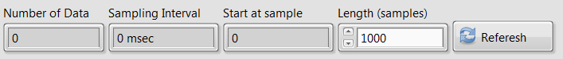

In the Navigator mode, the user selects the number of samples he/she wants to plot.

Referesh key will plot the data.

The user can move the window using the scroll bar. It simply changes the the starting sample for plotting.

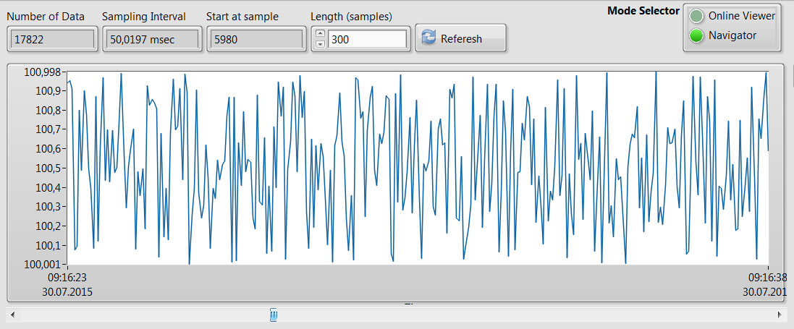

#### Multiple plots

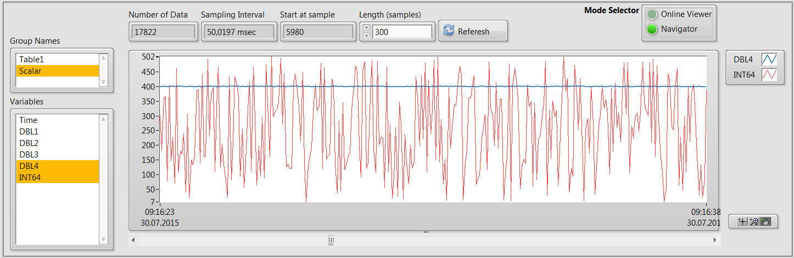

Legends automatically adjusted to the selected variables.

By right-clicking on the legend, additional functions will appear.

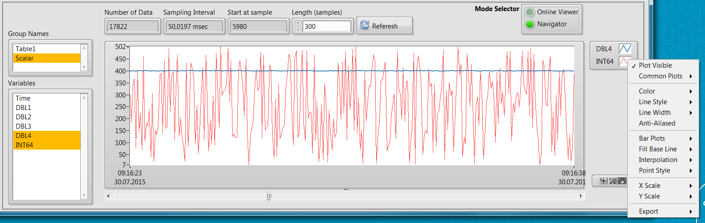

For example:

* Changing the plot type and interpolation

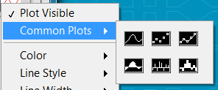

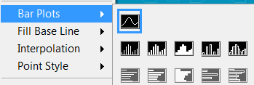

* Cosmetic settings such as color, line width, and line style (dashed, dotted, …)

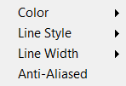

* Additional export setting for the plotted data

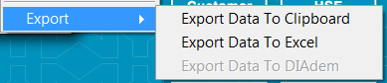

#### Graph Pallets

It provides the opportunity to zoom in/out with different functions and even navigate manually in the selected window.

 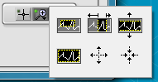

### Online Viewer Mode

In this mode, the TDMS file is used to store data online.

The user determines the window size, and the last data are plotted. As new data are streamed into the TDMS file, the window automatically moves.

# Revision History

| **Rev.** | **Reason for issue** | **Date** | **Prepared by | Approved by** |
| --- | --- | --- | --- |
| 01 | First issue | July 30, 2015 | EP | EP |